A Special Note
From Your Southern Shores Volunteer Fire Department

Fire Prevention Tip for July 2014

Firework Safety

Fireworks are responsible for thousands of burns and eye injuries every year. As we approach the season of firework festivities, it is important to understand how, by following a few simple rules, everyone can responsibility enjoy these events.

Be Careful:
- If you want to see fireworks, go to a public show put on by experts.
- Do not use consumer fireworks.
- Keep a close eye on children at event, where fireworks are used
Facts:
- In 2011, almost 18,000 fires were started by fireworks
- Sparklers cause almost 16% of firework injuries

Did you know?

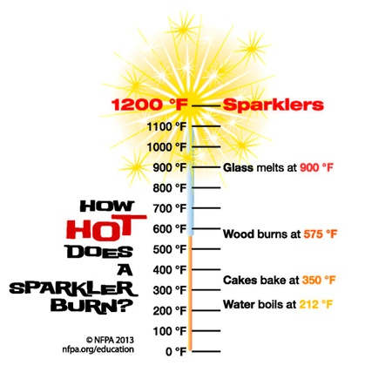
Interested in becoming a Fire Fighter? We are always eager to welcome new recruits. Come to a training session on any Wed evening at 7:00 or inquire at the station. We are also excited to welcome Junior Fire Fighters, starting at 16 years of age, interested in learning a new skill. Please contact our office for additional information.

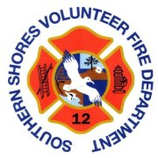
www.ssvfd.net
info@ssvfd.net
252-261-2272
https://www.facebook.com/SouthernShoresVolunteerFireDepartment

