A Special Note
From Your Southern Shores Volunteer Fire Department

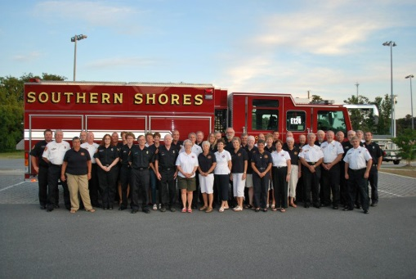

In our efforts to continue fire prevention education, we would like to provide you with a “Fire Prevention Tip” every month. It is our goal to ensure continuous safety through volunteer efforts to aid in the ongoing protection of our community and the residents of Southern Shores.

Fire Prevention Tip for March 2014

It’s that time of year again…..Daylight Savings Time. Don’t forget to change the batteries in your smoke detector.

Interested in becoming a Fire Fighter? We are always eager to welcome new recruits. We are also excited to welcome Junior Fire Fighters, starting at 16 years of age, interested in learning a new skill. Please contact our office for additional information.

www.SSVFD.net
info@ssvfd.net
252-261-2272
www.facebook.com/SouthernShoresVolunteerFireDepartment

